Chapter 3, Solution 24

Consider the circuit below.

1 Ω
4 Ω
2 Ω
1 Ω
+
_
V_{o}
8 Ω
4 A
2 A
2 Ω
V₃
V₂
V₁
V₄

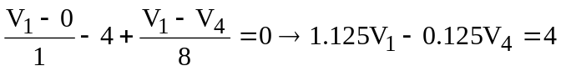 (1)
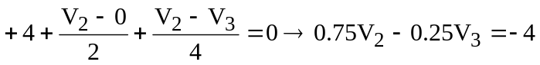 (2)
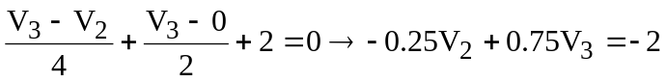 (3)
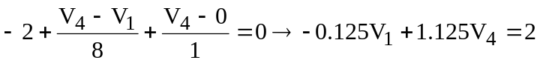 (4)

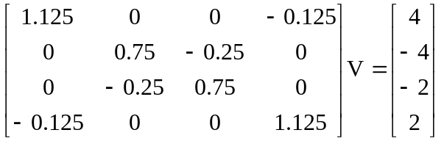

Now we can use MATLAB to solve for the unknown node voltages.

>> Y=[1.125,0,0,-0.125;0,0.75,-0.25,0;0,-0.25,0.75,0;-0.125,0,0,1.125]

Y =

1.1250 0 0 -0.1250
0 0.7500 -0.2500 0
0 -0.2500 0.7500 0
-0.1250 0 0 1.1250

>> I=[4,-4,-2,2]'

I =

4
-4
-2
2

>> V=inv(Y)*I

V =

3.8000
-7.0000
-5.0000
2.2000

V_{o} = V₁ – V₄ = 3.8 – 2.2 = 1.6 V.

